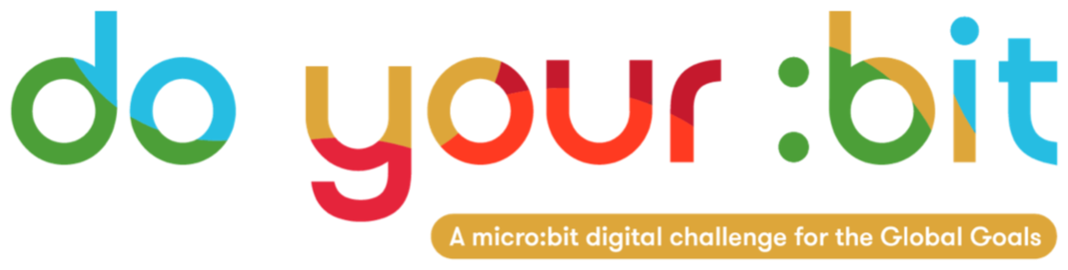

Quality Education

Introduction to Goal 4 - Quality Education

Use this guide to introduce Global Goal 4, Quality Education to your students.
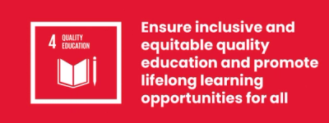

What is Global Goal 4?
Sustainable Development Goal 4: Quality Education is one of the 17 Sustainable Development Goals established by the United Nations in 2015. You can find out more about the Goals in our introductory guide.
Sustainable Development Goal 4 (SDG 4) is the education goal. It aims to ensure inclusive and equitable access to education and promote lifelong learning opportunities for all. Education helps us achieve many other goals. It can be a pathway to growth, a boost to public health and a stepping stone towards peace.

Activities
Below are some ideas to help bring Goal 4 to life for your students. They work as stand-alone activities or in sequence.

Activity 1: Exploring equal access to Quality Education

In this activity, students will be introduced to the concept of equality in terms of access to education.
Length - 15 min
Show your students this video discussing education.
https://www.youtube.com/watch?v=fE9dYM-P_l0

Reflect on the video
- Ask students to reflect on what they've just watched.
  - What was most interesting?
  - How did it make you feel?
  - How does the conversation relate to your own life?

Investigate education equality through data
- Explain that Global Goal 4: Quality Education is all about whether students around the world can access education equally, and whether they are learning what they need to succeed.
- Display or hand out a copy of the map demonstrating the unequal nature of access to education around the world. Click to enlarge it on screen or this page can be downloaded as a word document.
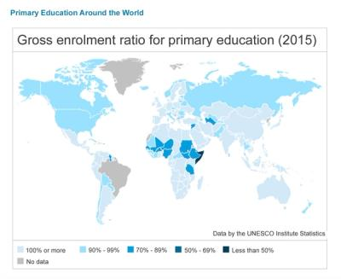
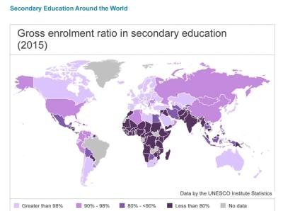

Discussion around maps
- Ask students to discuss the following questions:
  - What does the data show about education access in their own country and continent?
  - How does this compare with other countries and continents in the world?
  - Do students think that there is fair access to education across the world?
  - What are some reasons why students might not be able to access education? (e.g. no school nearby, having to work, child marriage, no internet access, war, poverty)
  - What kinds of things do we need in order to access education (e.g. building schools, training and recruiting teachers, internet access, safe communities, laws to protect children)
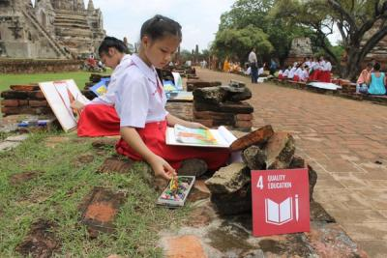

Activity 2: Be a fact-ivist - Dive into data

In this activity students will dive into data on education and create an infographic poster.
Length - 30 min

Investigate data facts
Ask students to work individually, in pairs or small groups. Start by looking at the data facts listed below:
SDG 4 Data Facts
- More than half of all refugee children do not go to school.
- Less than 30% of the world’s science, technology, engineering and maths researchers are women.
- Only 17% of countries have laws to help students with disabilities in school.
- 70% of young people say that they cannot explain climate change.
- One third of 11- to 15-year-olds have been bullied in school.
- Discuss which facts students are interested in.
  - Why do they think this is important?
  - Why might it be the case?
  - Can they think of ways to fix this issue?

Infographic poster creation
- Students should choose a fact that they feel passionate about, and then create an infographic poster to bring the fact to life.
- A great infographic visualises data in order to grab attention and send a message. Posters should include:
  - A) A clear message or headline
  - B) A visualisation which helps you understand the data
  - C) Something to make you care
You can find examples here.
When finished, you can share your posters with the world on social media and tag @theworldslesson to reach a global audience!
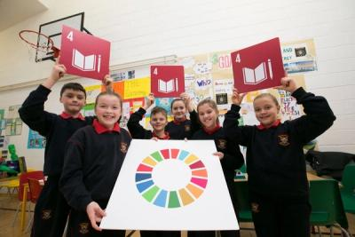

Activity 3: Exploring what helps and hinders learning

In this activity students will think about the different ways that children learn and what that means in terms of delivering a quality education for all children.
Length 45 min

Introduction
- Ask the students the following questions in order to highlight that everyone learns differently:
  - How do you like to learn?
  - What helps you learn best?
  - When you get confused in a lesson, what helps you? Does that help everyone?
  - What type of learner are you? If students are not sure what this means, explain they are about to explore it.

Exploring how we learn
Types of learner
- Write up the following list for the students to see:
  - Visual learning
  - Auditory learning
  - Hands-on learning
- Ask students if they know what these terms mean, before giving 1 or 2 examples like those listed below.
- Then ask the students for more examples and create a list for each one together.
Visual (looking at pictures, posters, flashcards, books and graphs)
Auditory (listening to something like a discussion, conversation, song, video or audio book)
Hands-on (practical experience, learners start doing a process themselves)
- Ask students to raise hands - who thinks they are a visual/auditory/hands-on learner or a mixture?
  - Did everyone answer the same or not?
  - What if we asked students in other schools, do you think their answers would be the same or different?
  - Why/why not?
Learning activities
- Now focus the students on activities that are often part of their lessons. Ask them to think about some of their favourite activities to do in lessons. Ask them to write a list of these activities or note them on sticky-notes. Examples could include reading a book / watching a video / researching on the internet.
- Once they have a list together, explore their ideas and ask:
  - Why do you think these activities help you learn?
  - Do any activities have things in common?

Exploring our barriers to learning
Remind students that the aim of Global Goal 4 is to ensure all children have a quality education. Ask students to look at the list of activities and think about their own learning environment.
Consider your learning environment
- In our school/classroom/playground what barriers to learning do we encounter?
- There are no right or wrong answers, the aim is to get students discussing the topic and thinking about common things that prevent learning e.g. lack of space, broken equipment, lack of resources, loud or cold environment etc.
Widen the discussion
- These activities can be used to spark a discussion around improving access to education in your community.
  - Is there anything you’d like to change about your education?
  - Can you think of a way to help children that cannot currently access education?
  - Can you think of ways to make this happen? Are there existing solutions that we can learn from?
Use this reflective discussion to highlight the need for Global Goal 4.
